APPLECROSS SENIOR HIGH SCHOOL
YEAR 12 HUMAN BIOLOGY TEST 1
The Immune System and the Cell Membrane

PART I

Multiple Choice

Choose the most appropriate answer and indicate on the separate multiple choice answer sheet provided.

1. Pathogens are microbes that
a) are highly contagious
b) cause disease
c) are eukaryotic cells (with a nucleus)
d) are prokaryotic cells (with no nucleus)

2. Active artificial acquired immunity is a result of:
a) vaccination
b) antibodies passed on from mother to baby through breast milk
c) antibodies passed on from mother to foetus through the placenta
d) contact with a pathogen

3. The immune cell that allows for the subsequent recognition of an antigen resulting in a secondary response is called a(n)
a) helper T-cell
b) antigen-presenting cell
c) plasma cell
d) memory cell

4. Of the different types of Leucocytes, which are involved in the formation of T-cells and B-cells?
a) Monocytes
b) Basophils
c) Eosinophils
d) Lymphocytes

5. Plasma B cells circulate in the blood, lymph and extracellular fluids. Their chief function is to
a) secrete specific antibodies to attach to the antigens on the surface of pathogens
b) secrete memory T-cells so the immune response will be quicker on a second invasion
c) initiate the cell-mediated immune response
d) stimulate the inflammatory response

6. Narrow spectrum antibiotics are substances that
a) are only sensitive to particular pathogens
b) disable or destroy micro-organisms
c) are effective against viruses but not bacteria
d) are only used to treat established infections

7. An important difference between T-cells and B-cells is

 | T-Cells | B-cells
a | Connect to antigens right on the surface of the invading virus or bacteria | Only connect to virus antigens on the outside of infected cells
b | Attack invaders outside the cell | Attack invaders inside the cells
c | Only connect to virus antigens on the outside of infected cells | Connect to antigens right on the surface of the invading virus or bacteria
d | Mature in the thyroid | Mature in the bone marrow

8. Killer T-cells are also known as
a) Memory T-cells
b) Suppressor T-cells
c) Helper T-cells
d) Cytotoxic T-cells

9. Ig is the abbreviation used for an Immunoglobulin. One Ig usually contains two pairs of polypeptide chains. The ends of these chains are referred to as ‘variable portions’. What common name is given to Immunoglobulins?
a) Antibodies
b) Cytotoxins
c) Macrophages
d) Antigens

10. There are several types of vaccinations. One such vaccination includes the use of ‘attenuated’ organisms. This means the organisms
a) toxins are neutralised
b) are dead
c) are made less virulent but are alive
d) are made into an inoculation

11. Which of the following is the hallmark of the humoral immune response?

a) Phagocytosis
b) Binding of antibody to the antigen
c) Cell lysis by T cells
d) Antigen presentation

12. The phospholipid bilayer of the cell membrane is made up of parts that are hydrophobic and hydrophilic. The hydrophilic parts are located:
a) in the middle
b) on the bottom only
c) the head portion of the phospholipid
d) the tail portion of the phospholipid

13. There are several types of protein that carry out specific functions as part of the cell membrane, making up only 2% of the molecules in the membrane but 55% of the weight. Which is not one of these proteins?
a) Receptor proteins
b) Channel proteins
c) Messenger proteins
d) Carrier proteins

14. Cells suspended in a hypertonic solution, due to osmosis, will
a) swell
b) shrivel
c) remain the same
d) enlarge the cell membrane

15. Vesicular transport of substances across the cell membrane requires
a) energy
b) simple diffusion
c) carrier proteins
d) no energy

16. Pinocytosis and Phagocytosis are involved in endocytosis. These transport systems move respectively
a) Na ions
b) extracellular and intercellular fluids
c) Na ions and Cl ions
d) liquids and solids

17. Sometimes molecules need to be transported into a cell or out of a cell against a concentration gradient. This refers to the
a) kinetic energy of molecules is greater in the high concentration areas
b) kinetic energy of molecules is less in the low concentration areas
c) movement of molecules from areas of relatively low concentration to high concentration
d) movement of molecules from areas of relatively high concentration to low concentration

18. A “foreign” molecule which can invoke the immune response is called a(n):
a) antibody
b) immunoglobulin
c) antigen
d) MHC molecule

19. The diagram shown below illustrates

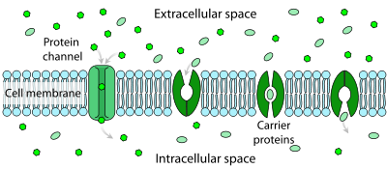

a) facilitated diffusion
b) simple diffusion
c) osmosis
d) active transport

20. Refer to the diagram below, both O₂ and CO₂ are small uncharged solute particles. What will eventually happen, due to the concentration gradient of the system?

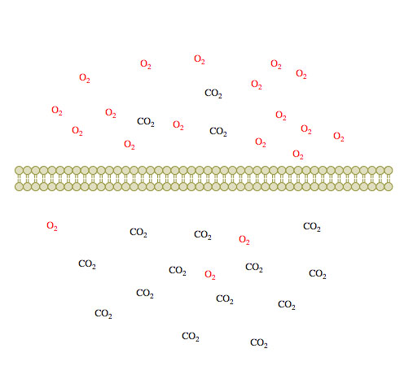

a) Only CO₂ will move from the bottom to the top across the cell membrane
b) Only O₂ will move from the top to the bottom
c) Both molecules will move to the bottom
d) Both molecules will spread out evenly across the cell membrane on both sides

END OF PART 1 THE MULTIPLE CHOICE SECTION

NAME ____________________________________

PART II

21. Differentiate between a primary and secondary immune response. Provide two differences, well explained.

_______________________________________________________________________

________________________________________________________________________

________________________________________________________________________

________________________________________________________________________

________________________________________________________________________

________________________________________________________________________

________________________________________________________________________

________________________________________________________________________

________________________________________________________________________

________________________________________________________________________

________________________________________________________________________
(4 marks)

22. Cystic fibrosis is a genetic disease that results in thick mucus secretions that clog up air passages in the lungs. Faulty chloride ion channels keep Cl⁻ and Na⁺ in the cells that line the airways increasing the intracellular ion concentrations. How does this cause the mucus in the airways to become thick? (hint: Think about what passive transport mechanisms are involved).

________________________________________________________________________

________________________________________________________________________

________________________________________________________________________

________________________________________________________________________

________________________________________________________________________
(2 marks)
23. When the cell membrane is referred to more emphasis is placed on phospholipids and proteins compared to cholesterol, glycoproteins and glycolipids. State briefly the functions of the latter 3 components of the cell membrane.

Cholesterol __________________________________________________________

____________________________________________________________________

Glycoproteins ________________________________________________________

____________________________________________________________________

Glycolipids __________________________________________________________

____________________________________________________________________
(3 marks)

24. Construct a table showing the differences between Natural and Artificial Immunity. Include in your answer:
(i) the different categories of each type
(ii) how they are obtained
(ii) how it provides immunity. (6 marks)
Poorly constructed tables will incur a penalty (max=2 marks)

